# | Запрос и результат
a | SELECT name , telegram_contact  FROM student s  WHERE city = 'Казань'  ORDER BY  name desc  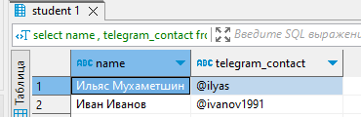
b | 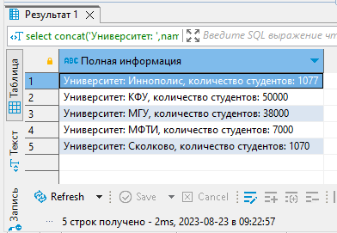  SELECT  concat('Университет: ',name,', количество студентов: ',size) AS "Полная информация"  FROM college c  ORDER BY "Полная информация"
c | 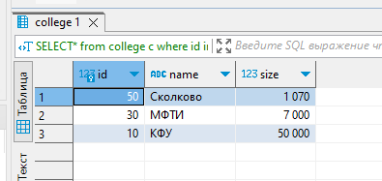  SELECT*  FROM college c  WHERE id in (10,30,50)  ORDER BY size, name
d | SELECT*  FROM college c  WHERE id not in (10,30,50)  ORDER BY size, name  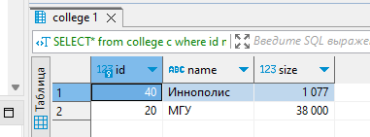
e | 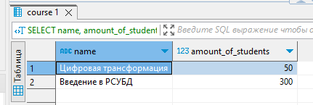  SELECT name, amount_of_students  FROM course c  WHERE  amount_of_students BETWEEN 27 AND 310  ORDER BY  name desc,amount_of_students desc
f | SELECT name  FROM course c  UNION  SELECT Name  FROM student s  ORDER BY  name desc  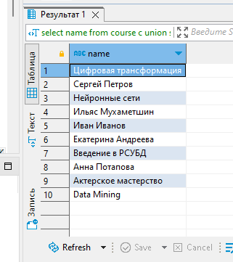
g | 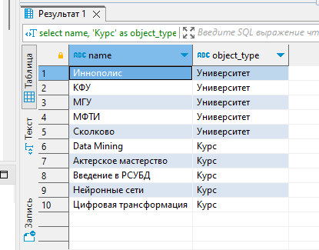  SELECT name, 'Курс' AS object_type FROM course c  UNION  SELECT name, 'Университет' AS object_type FROM college c2  ORDER BY object_type desc, name
h | 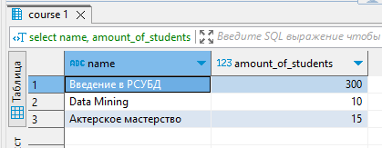  SELECT name, amount_of_students  FROM course c2  ORDER BY  (CASE when amount_of_students = 300 THEN 1 else amount_of_students end)  LIMIT 3
i | INSERT INTO course  (id,name,is_online,amount_of_students,college_id)  VALUES  (60,'Machine learning',False,17,(SELECT college_id FROM course WHERE name = 'Data Mining'))  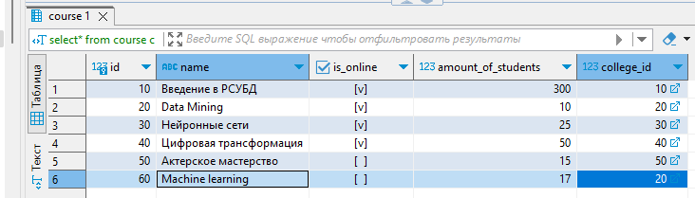
j | 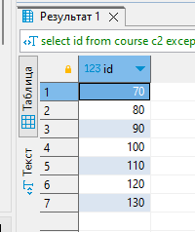  SELECT id FROM course c2  EXCEPT (SELECT id FROM student_on_course soc2)  UNION  SELECT id FROM student_on_course soc  EXCEPT (SELECT id FROM course c)  ORDER BY 1
k | SELECT student.name AS student_name,  course.name AS course_name,  college.name AS college_name,  student_ON_course.student_rating AS student_rating  FROM student  JOIN college  ON student.college_id = college.id AND college.size > 5000  JOIN course  ON course.college_id = student.college_id  JOIN student_on_course  ON student_ON_course.student_id = student.id  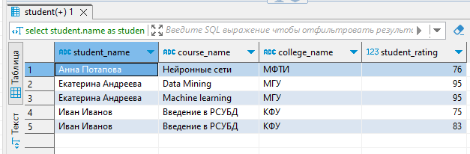  WHERE student_ON_course.student_rating > 50  ORDER BY 1,2
l | SELECT  s1.name AS student_1,  s2.name AS student_2, s1.city  FROM student s1  JOIN student s2 ON s1.city = s2.city  WHERE s1.name > s2.name  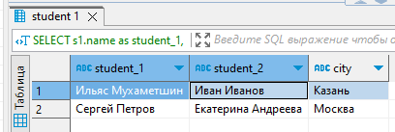
m | 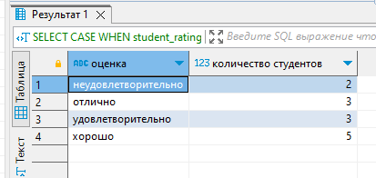  SELECT  CASE  WHEN student_rating < 30 THEN 'неудовлетворительно'  WHEN student_rating >= 30 AND student_rating < 60 THEN 'удовлетворительно'  WHEN student_rating >= 60 AND student_rating < 85 THEN 'хорошо'  ELSE 'отлично'  END "оценка",  count(student_id) AS "количество студентов"  FROM  student_on_course soc  GROUP BY "оценка"  ORDER BY 1
n | SELECT  c.name AS "курс",  CASE  WHEN soc.student_rating < 30 THEN 'неудовлетворительно'  WHEN soc.student_rating >= 30 AND soc.student_rating < 60 THEN 'удовлетворительно'  WHEN soc.student_rating >= 60 AND soc.student_rating < 85 THEN 'хорошо'  ELSE 'отлично'  END AS "оценка",  COUNT(soc.student_id) AS "количество студентов"  FROM  student_on_course soc  INNER JOIN course c ON soc.course_id = c.id WHERE c.name<>'Machine learning'  GROUP BY  "курс",  "оценка"  ORDER BY  "курс",  "оценка"  